Updated 10/18/2020

**GNS3 LAB-1: creation and uses of appliances**

PREREQUISITE:

LAB 0 must be done

**PART 1: adding appliances form the market**

Go to <https://www.gns3.com/marketplace/appliances> to get new readymade appliances

Download: Ubuntu Desktop Guest and Windows

Open GNS3 and create a new project

File > new templet > use gns3a file

Select your Ubuntu.GNS3a file

Next > Next

Select version 20.04.vmdk and download   
*get the file for your software and unzip  
*user: osboxes pass: osboxes.org

Then select import and import the vmdk file you just downloaded

Repeat for the windows   
*password is Passw0rd!

**PART 2: adding appliances from ISO BIN IMAGE**

go to <http://tfr.org/cisco-ios/7200/> to get the c7200-adventerprisek9-mz.151-4.M.bin

Go to Edit > Preferences > Dynamips > IOS routers

Click new > run on the GNS3 VM > Next

New Image >browse > select your .bin > say yes to decompress > next till the template is done

Apply > ok

You should now see the c7200 router in the router section

**DELIVERABLE 1: Drag and drop the 3 new appliances to the project**  
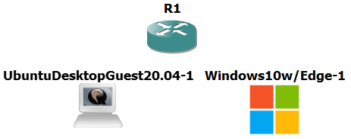

**PART 3: Adding a VM**

Go to preferences > VMware > new

Then add a exsisting windows or Linux VM to your project

**DELIVERABLE 2: show the config page similar to the following**

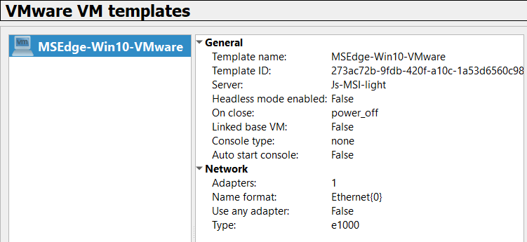

**PART 4: Networking**

Double click the router and go to the slots tab

Add a PA-8E in slot 1

Connect the devises to the router with the  button

To connect a VM you will need to click the override option in the computers network configuration

Highlight all devises and power them on with the green button

Lastly configure your router and network so the PCs can ping

**DELIVERABLE 3: show a successful log on for windows and Linux**  
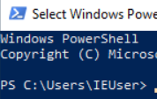  
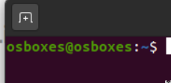

**DELIVERABLE 4: show a successful ping between two devices**

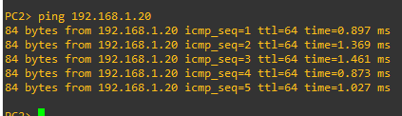

**DELIVERABLE 5: show your network is green**